Q1.Create massage box using tkinter library in python.

Solution:-

import tkinter  
from tkinter import messagebox  
m = tkinter.Tk()  
def func():  
 messagebox.showinfo("click Me ..","for go back !! ")  
b= tkinter.Button( m,text="say hello" , command = func).pack()  
b= tkinter.Button( m,text="Exit" , command = m.destroy).pack()  
m.mainloop()

OUTPUT:-

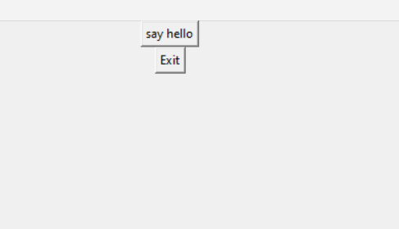 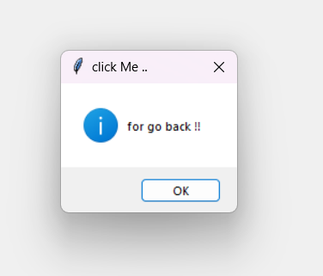

Output after Run Mssage after click on Say hello

Q2.Create blank window using tkinter library in python.

Solution:-

Q2.Create window and arc using tkinter library in python.

Solution:-

import socket

clientsocket =socket.socket(

socket.AF_INET,socket.SOCK_STREAM)

host=socket.gethostname()

port =9090

clientsocket.connect((host,port))

msg =clientsocket.recv(1024)

clientsocket.close()

print(msg.decode('ascii'))

OUTPUT:-

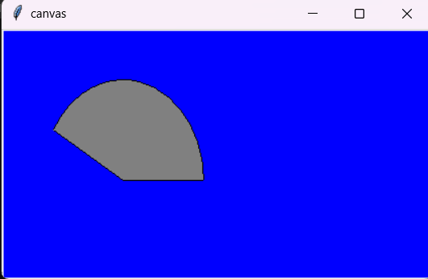

Q2.Create blank server using socket library in python.

Solution:-

# create server

import socket  
serversocket=socket.socket(  
 socket.AF_INET,socket.SOCK_STREAM)  
host = socket.gethostname()  
port =9090  
serversocket.bind((host,port))  
serversocket.listen(5)  
  
while True:  
 clientsocket,addr=serversocket.accept()  
 print("conneection initiated from %s" %str(addr))  
 msg='connection establised'+"\r\n"  
 clientsocket.close()

# server for user

import socket

clientsocket =socket.socket(

socket.AF_INET,socket.SOCK_STREAM)

host=socket.gethostname()

port =9090

clientsocket.connect((host,port))

msg =clientsocket.recv(1024)

clientsocket.close()

print(msg.decode('ascii'))